FRECUENCIA EN UN ESPECTROGRAMA
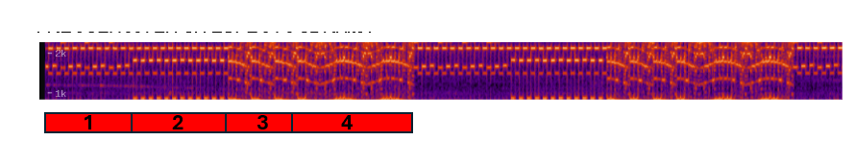

PUNTOS | FRECUENCIA ESTIMADA | valor representativo
1 | 1600-1446 hz (sube y baja) | $1,600Hz$
2 | 1772-1430hz | $1,772Hz$
3 | 1772-1578hz bajada progresiva, se repite | $1,772Hz$
4 | 1734-1595 cae y sube continuamente. | $1,734Hz$

Variables: Frecuencia (hz) vs tiempo (s)

t(x) | 0.08 | 0.2 | 0.38 | 0.55 | 0.67 | 0.82 | 1
F(y) | 1629 | 1446 | 1629 | 1446 | 1612 | 1446 | 1612

t(x) | 1.16 | 1.31 | 1.5 | 1.68 | 1.8 | 1.95 | 2.09
F(y) | 1446 | 1647 | 1446 | 1595 | 1446 | 1629 | 1446

t(x) | 2.26 | 2.44 | 2.58 | 2.76 | 2.88 | 3.07 | 3.2
F(y) | 1595 | 1430 | 1595 | 1446 | 1612 | 1462 | 1629

t(x) | 3.37 | 3.52 | 3.69 | 3.86 | 4.01 | 4.15 | 4.3
F(y) | 1430 | 1772 | 1415 | 1791 | 1446 | 1791 | 1430

t(x) | 4.47 | 4.60 | 4.79 | 4.94 | 5.09 | 5.23 | 5.38
F(y) | 1791 | 1430 | 1791 | 1446 | 1791 | 1446 | 1772

t(x) | 5.55 | 5.7 | 5.85 | 5.99 | 6.19 | 6.31 | 6.43
F(y) | 1446 | 1791 | 1446 | 1791 | 1430 | 1791 | 1415

t(x) | 6.63 | 6.75 | 6.95 | 7.07 | 7.24 | 7.34 | 7.45
F(y) | 1772 | 1446 | 1754 | 1446 | 1772 | 1772 | 1736

t(x) | 7.52 | 7.66 | 7.67 | 7.75 | 7.88 | 7.95 | 8.09
F(y) | 1754 | 1700 | 1682 | 1664 | 1629 | 1595 | 1772

t(x) | 8.28 | 8.38 | 8.5 | 8.59 | 8.67 | 8.76 | 8.9
F(y) | 1772 | 1718 | 1682 | 1682 | 1629 | 1612 | 1595

t(x) | 9.18 | 9.37 | 9.54 | 9.69 | 9.8 | 9.89 | 10.04
F(y) | 1772 | 1718 | 1664 | 1612 | 1612 | 1754 | 1772

t(x) | 10.21 | 10.38 | 10.43 | 10.5 | 10.61 | 10.65 | 10.76
F(y) | 1718 | 1700 | 1664 | 1664 | 1629 | 1595 | 1612

t(x) | 10.94 | 11.09 | 11.12 | 11.24 | 11.36 | 11.37 | 11.48
F(y) | 1612 | 1647 | 1629 | 1682 | 1736 | 1736 | 1772

t(x) | 11.57 | 11.68 | 11.85 | 12.02 | 12.3 | 12.39 | 12.52
F(y) | 1791 | 1791 | 1754 | 1754 | 1664 | 1629 | 1629

t(x) | 12.59 | 12.72 | 12.89 | 13.11 | 13.19 | 13.41 | 13.59
F(y) | 1612 | 1612 | 1664 | 1700 | 1718 | 1791 | 1772

t(x) | 13.71 | 13.88 | 13.96 | 14.1 | 14.27 | 14.36 | 14.47
F(y) | 1772 | 1647 | 1700 | 1682 | 1612 | 1612 | 1612
aprox 15 segundos se repite el patron
Formula para hallar frecuencias:

$f=\frac{1.44}{(R_{2}+2R_{3})⋅C_{1}}$
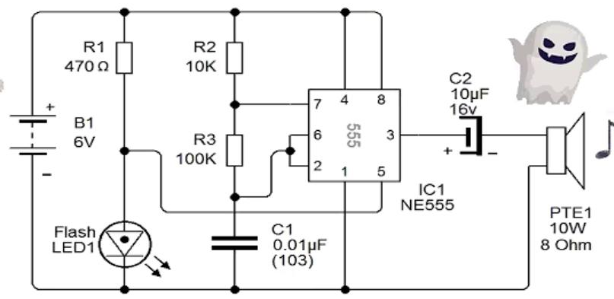
R3 = 100kΩ ; R2 = 10kΩ

$f=\frac{1.44}{(10,000+2(100,000))×0.01×10^{-6}}≈685.71Hz$
"El circuito realiza un barrido automático de frecuencias gracias a la red de control del condensador, haciendo que la frecuencia oscile dinámicamente entre $1,000Hz$ y $1,800Hz$ en lugar de mantenerse estática.

